EMERGENCY CONTACT PARENTAL CONSENT FORM
55 PA CODE CHAPTERS 3270.124(a)(b), 3270.181 & 182, 3280.124(a)(b), 3280.181 & 182, 3290.124(a)(b), 3290.181 & 182

CHILD’S NAME | BIRTH DATE
ADDRESS

MOTHER’S NAME/LEGAL GUARDIAN | HOME TELEPHONE NUMBER
E-MAILADDRESS | MOBILE TELEPHONE NUMBER
ADDRESS

BUSINESS NAME | BUSINESS TELEPHONE NUMBER
ADDRESS

FATHER’S NAME/LEGAL GUARDIAN | HOME TELEPHONE NUMBER
E-MAILADDRESS | MOBILE TELEPHONE NUMBER
ADDRESS

BUSINESS NAME | BUSINESS TELEPHONE NUMBER
ADDRESS

EMERGENCY CONTACT PERSON(S) NAME TELEPHONE NUMBER WHEN CHILD IS IN CARE

PERSON(S) TO WHOM CHILD MAY BE RELEASED NAME ADDRESS TELEPHONE NUMBER WHEN CHILD IS IN CARE

NAME OF CHILD’S PHYSICIAN/MEDICAL CARE PROVIDER | TELEPHONE NUMBER
ADDRESS

SPECIAL DISABILITIES (IF ANY) | ALLERGIES (INCLUDING MEDICATION REACTIONS)
MEDICAL OR DIETARY INFORMATION NECESSARY IN AN EMERGENCY SITUATION | MEDICATION, SPECIAL CONDITIONS
ADDITIONAL INFORMATION ON SPECIAL NEEDS OF CHILD

HEALTH INSURANCE COVERAGE FOR CHILD OR MEDICALASSISTANCE BENEFITS | POLICY NUMBER (REQUIRED)
PARENTS SIGNATURE IS REQUIRED FOR EACH ITEM BELOW TO INDICATE PARENTAL CONSENT
OBTAINING EMERGENCY MEDICAL CARE | ADMIN. OF MINOR FIRST - AID PROCEDURES
WALKS AND TRIPS | SWIMMING
TRANSPORTATION BY THE FACILITY | WADING
PERIODIC REVIEW

SIGNATURE OF PARENT OR GUARDIAN DATE

SIGNATURE OF PARENT OR GUARDIAN DATE

03891A ORIGINAL CY 867 - 1/93

Dear Parents,

The following are forms that need filled out for us to enter onto the Teaching Strategies GOLD website. The information that is entered is only seen by me. Teaching Strategies GOLD is the type of assessment that we do on the children three times/year. The information that we observe on the children is entered in to the computer and then we print it off for you to see. If you have any further questions, please feel free to ask. Make sure to fill out the front and back of the paper.

Thank you!

Danielle Graham
Director

Toddlers and Preschoolers, Head Start State Supplemental Assistance Programs, Keystone STARS Child Care Centers and Pennsylvania Pre-K Counts programs.
Early Learning Network: A Guide for Parents
In Pennsylvania, the Office of Child Development and Early Learning (OCDEL) provides funding to a variety of statewide early education programs including: Early Intervention Programs for Infants,

Electronic data systems are needed to maintain individual child records and to collect data for improving early childhood programs. OCDEL and your local program use this data to make sure that early childhood programs are of high quality and will enhance the development of young children.

What is the Early Learning Network (ELN)?

The Early Learning Network (ELN) is Pennsylvania’s electronic data system for gathering information on early childhood programs and for studying the development of children in those programs. ELN combines information about the program including the quality and experience of the staff, with information on your child’s development over time. This information is then used to build and maintain high quality early childhood programs.

ELN benefits you, your child, and your child’s teachers or therapists by providing:

 Information on your child’s development in his/her early childhood program;  Information for the teacher to improve classroom instruction;
 Ideas on how to prepare your child for school; and
 Strategies to help children who have different kinds of learning needs.

Pennsylvania’s early childhood programs also benefit from information in ELN. The information in ELN will be used to maintain a high level of quality across all early childhood programs, to provide information on the types of programs that work best for children, and to assure that OCDEL is accountable for state funding that is invested in early childhood programs.

What Information is Collected in ELN?

The information collected in ELN was determined by statewide focus groups that included parents of young children, early childhood teachers, Early Intervention therapists, researchers, and administrators of early childhood programs. The focus groups reviewed the latest early childhood research to determine what information would be most helpful when making decisions about program quality.

As a family participating in a state funded early childhood program, you may find it helpful to know what data is collected about your child and family. Information collected in ELN includes:

 Program demographics (number of days open per week, number of hours per day, education and experience of teachers or therapists, etc.);
 Family demographics (name, address, contact information, etc);  Child demographics (date of birth, program enrollment, etc.);
 For children in Early Intervention, your child’s Individualized Family Service Plan (IFSP) or Individualized Education Plan (IEP); and

1
 Information on your child’s progress as measured through an ongoing assessment of his/her development.

All of the information that you provide about your child and family will be maintained securely in ELN, following all state and federal data security requirements. Each child in ELN is given a unique identifying number, which provides security, continuity, and consistency.

As part of the process to give your child an identifying number, you may be asked for your child’s Social Security Number (SSN). Providing your child’s SSN is voluntary. Your decision to provide or not provide your child’s SSN will not impact on your child’s enrollment in any OCDEL program.

ELN only asks for your child’s SSN once during the process of assigning your child a unique identifying number. By providing your child’s SSN, you help OCDEL ensure that all the data entered into ELN is as accurate as possible and that any required state or federal reporting is as accurate as possible. Your child’s SSN is never used in analyzing data.

Federal law requires OCDEL to provide the legal authority for its request for a social security number. That authority is different for each program, as follows: Infant/Toddler and Preschool Early Intervention program - 11 P.S. § 875-305; Head Start State Supplemental Assistance program - 24 P.S. § 15-1505-D(a); Pennsylvania Pre-K Counts – 24 P.S. §15-1513-D(1)); Accountability Block Grant Pre-Kindergarten program - 24 P.S. Section 25-2599.2 (e)(1); and Keystone STARS Child Care Centers - 62 P.S. §§ 911(a)(2), 911(b), 916, 1016, 1018

Who Can See My Child’s Information?

All information about your child is kept secure. All federal and state confidentiality, privacy and security requirements are honored. This means that:

 Your child’s program will have access to your child’s personally identifiable information;  A child’s teacher or therapist will only be able to see information about the children with
whom they work;
 Reports to the state and federal government do not identify specific children; and
 Information about your child will not be shared outside of your child’s program, except as permitted by law.

How will ELN Measure My Child’s Progress?

ELN makes it possible to measure quality of early childhood programs and the impact that quality has on children’s development. It will do this by gathering information about children’s learning and development in areas such as:
 Approaches to Learning;  Cognitive Thinking;
 Physical Development;
 Language and Literacy Development  Social and Emotional Development

The United States Department of Education, Office of Special Education Programs (OSEP) requires every state to collect accountability data to determine the effectiveness of the Part C (Infant/Toddler) and Part B (Preschool) Early Intervention programs. Progress for children participating in Early Intervention is determined in the following three child outcome measures:
 Positive Social Emotional Skills (including social relationships);
 Acquisition and Use of Knowledge and Skills (including early language/communication); and  Use of Appropriate Behaviors to Meet Needs.

2 Updated 3/14/12

Information on children’s progress will be gathered using an authentic assessment tool. An authentic assessment tool is based on observations of your child in typical activities in their program. There are no formal tests, no traditional grades, and no “pass” or “fail.” With these authentic assessment tools, your child’s teacher will collect information about your child’s development in a number of different ways. For example, your child’s teacher or therapist will collect samples of your child’s work, ask you what you’ve noticed about your child’s development, and make observations during classroom activities or therapy sessions.

Teachers and therapists will observe and document your child’s learning over time. In early childhood programs, information on your child’s progress will be gathered several times during the year. In Early Intervention Programs, your child’s progress will be gathered at the beginning and end of their participation in the Early Intervention program.

How can Parents and Families Help?

As a parent, you have a great deal of information about your child. Ask your child’s teacher about your child’s progress; talk with your child’s therapist about what your child is learning and doing at home and in the community; and, most importantly, ask about ways that you can help your child to learn, grow and develop.

OCDEL values the time you spend helping us continue to shape the policies and programs that benefit children across the Commonwealth.

For more information contact ELN ra-eln@pa.gov

3 Updated 3/14/12

Information to Fill out Child’s First & Last Name:
_______________________________________________________

Ethnicity: ___ Hispanic ___Non-Hispanic ___Unknown

Race: ____________________________

Date of Birth: __________________________

Is English the first language of the child: ___Yes ___No

Primary Guardian: ____________________________________________

Your Date of Birth: __________________________

Relationship to Child: ___________________________

Address: ____________________________________________________

City: ____________________________

School District of Residence: _____________________________

Education Status: _______________________________

Employment Status: ___ Full time (30 hrs/week plus) ____Part-time (less than 30 hrs) ____More than one part-time ____Seasonal ___Student Full-time ___Student Part-Time ___No Employment

1. How often do you read to your child?
___ 1/day ___ 1/week ___1/month ___less than 1/month

2. How many books are in your home?
___ less than 5 ___5-10 books ___11-20 books ___ 20 or more

3. How many siblings does your child have? ________ 4. How many people live in your household? _______ 5. Your annual Household Income Level:
___ $5000 or less ___$5001-$10,000 ___$10,001-$15,000 ___$15,001-$20,000 ___$20,001-$25,000 ___$25,001-$30,000 ___$30,001-$35,000 ___$35,001-$40,000 ___$40,001-$45,000 ___$45,001-$50,000 ___$50,001-$60,000 ___$60,001-$70,000 ___$70,001-$100,000 ___More than $100,000

6. Child’s birth weight:
___ Less than 3 lbs 4 oz ___ 3 lbs 4 oz to 5 lbs 8 oz ___More than 5 lbs 8 oz

7. Mother’s Birth Year: ________ 8. Type of Insurance:
___ CHIP ___Medical Assistance ___Private Insurance ___None 9. Has your child been diagnosed with any of the following, please put a
check by it:
___Anemia ___Asthma ___ Diabetes ___Obesity ___None 10.Does your child have a dentist that he/she sees regularly?

Dear Parents-

The letter that is attached explains where Little Lights Learning Center will be relocated in the event of an emergency. Please keep the letter at home for yourself in the event of an emergency. We are asking that you please sign and date this letter stating that you have received the updated information. Thank you for your help!

Danielle Graham

Director

__________________________ (Child’s Name)

__________________________ (Parent Signature)

__________________________ (Date)

To the Parent (s)/Guardian (s) of Children at Little Little Lights Learning Center of Carlisle United Methodist Church:

This letter is to assure you of our concern for the safety and welfare of children attending Little Lights Learning Center. Our Emergency Plan provides for response to all types of emergencies. Depending on the circumstance of the emergency, we will use one of the following protective actions:

• Immediate evacuation: Students are evacuated to a safe area on the grounds of the facility in the event of a fire, etc. ** Parking lot of Bosler Library

• In-place sheltering: Sudden occurrences, weather or hazardous materials related, may dictate that taking cover inside the building is the best immediate response. Hallway outside Fellowship Hall on first level

• Evacuation: Total evacuation of the facility may become necessary if there is a danger in the area. In this case, children will be taken to the relocation facility at:
Close Facility: Carlisle Historical Society
Distant Facility: Otterbein United Methodist Church

• Modified Operation: May include cancellation/postponement or rescheduling of normal activities. These actions are normally taken in case of a winter storm or building problems (such as utility disruptions) that make it unsafe for children but may be necessary in a variety of situations.

Please listen to (Channel 21, station 580, 97.3, 99.3, 94.9 FM) for announcements relating any of the emergency actions listed above.

We ask that you not call during the emergency. This will keep the main telephone line free to make emergency calls and relay information.

The form designating persons to pick up your child is included with this letter for you to complete and have returned to the day care facility upon enrollment. This form will be used every time your child is released. Please ensure that only those persons you list on the form attempt to pick up your child.

I specifically urge you not to attempt to make different arrangements during an emergency. This will only create additional confusion and divert staff from their assigned emergency duties.

In order to assure the safety of your children and our staff, I ask your understanding and cooperation. Should you have additional questions regarding our emergency operating procedures contact: Danielle Graham w #717-249-5130 c.#717-422-7458.

Sincerely,

Danielle Graham

Director

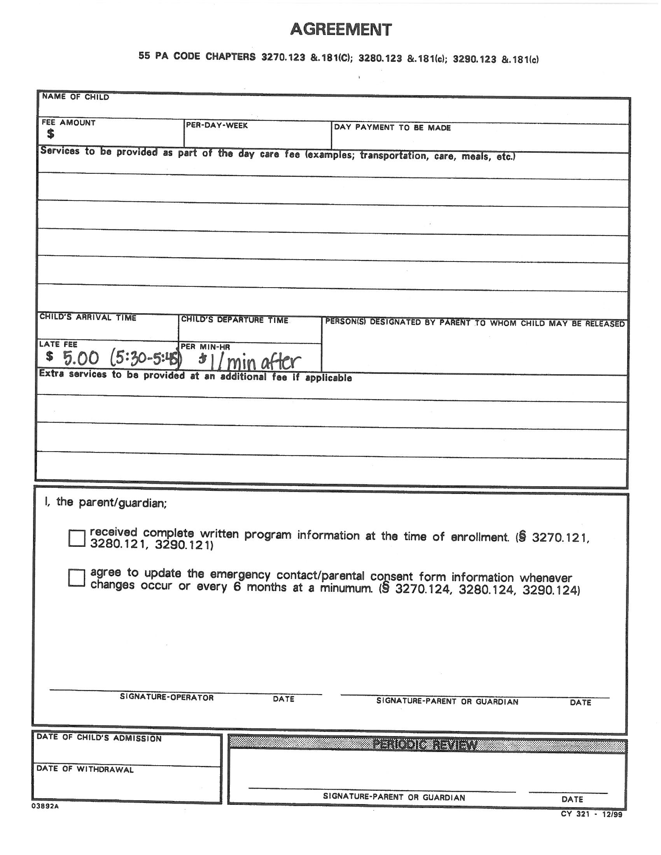

CHILD HEALTH REPORT (55 PA CODE §§3270.131, 3280.131 AND 3290.131)
Parents may write immunization dates; health professional should verify and complete all data.
Parent/Provider fill in this part.

CHILD’S NAME: (LAST) (FIRST) | PARENT/GUARDIAN:
DATE OF BIRTH: HOME PHONE: | ADDRESS:
CHILD CARE FACILITY NAME:
FACILITY PHONE: COUNTY: | WORK PHONE:
 I authorize the child care staff and my child’s health professional to communicate directly if needed to clarify information on this form about my child.

PARENT’S SIGNATURE:

DO NOT OMIT ANY INFORMATION
This form may be updated by a health professional. Initial and date any new data. The child care facility needs a copy of the form.
HEALTH HISTORY AND MEDICAL INFORMATION PERTINENT TO ROUTINE CHILD CARE AND DIAGNOSIS/TREATMENT IN EMERGENCY (DESCRIBE, IF ANY):  NONE
DESCRIBE ALL MEDICATION AND ANY SPECIAL DIET THE CHILD RECEIVES AND THE REASON FOR MEDICATION AND SPECIAL DIET. ALL MEDICATIONS A CHILD RECEIVES SHOULD BE DOCUMENTED IN THE EVENT THE CHILD REQUIRES EMERGENCY MEDICAL CARE. ATTACH ADDITIONAL SHEETS IF NECESSARY.  NONE
CHILD’S ALLERGIES (DESCRIBE, IF ANY):  NONE
LIST ANY HEALTH PROBLEMS OR SPECIAL NEEDS AND RECOMMENDED TREATMENT/SERVICES. ATTACH ADDITIONAL SHEETS IF NECESSARY TO DESCRIBE THE PLAN FOR CARE THAT SHOULD BE FOLLOWED FOR THE CHILD, INCLUDING INDICATION OF SPECIAL TRAINING REQUIRED FOR STAFF, EQUIPMENT AND PROVISION FOR EMERGENCIES.
 NONE
IN YOUR ASSESSMENT, IS THE CHILD ABLE TO PARTICIPATE IN CHILD CARE AND DOES THE CHILD APPEAR TO BE FREE FROM CONTAGIOUS OR COMMUNICABLE DISEASES?
 YES  NO IF NO, PLEASE EXPLAIN YOUR ANSWER:
HAS THE CHILD RECEIVED ALL AGE APPROPRIATE SCREENINGS LISTED IN THE ROUTINE PREVENTIVE HEALTH CARE SERVICES CURRENTLY RECOMMENDED BY THE AMERICAN ACADEMY OF PEDIATRICS? (SEE SCHEDULE AT WWW.AAP.ORG)   YES  NO |  | NOTE BELOW IF THE RESULTS OF VISION, HEARING OR LEAD SCREENINGS WERE ABNORMAL. IF THE SCREENING WAS ABNORMAL, PROVIDE THE DATE THE SCREENING WAS COMPLETED AND INFORMATION ABOUT REFERRALS, IMPLICATIONS OR ACTIONS RECOMMENDED FOR THE CHILD CARE FACILITY.
 |  | VISION (subjective until age 3)
 |  | HEARING (subjective until age 4)
 |  | LEAD
RECORD DATES OF IMMUNIZATIONS BELOW OR ATTACH A PHOTOCOPY OF THE CHILD’S IMMUNIZATION RECORD
IMMUNIZATIONS | DATE | DATE | DATE | DATE | DATE | COMMENTS
HEP-B
ROTAVIRUS
DTAP/DTP/TD
HIB
PNEUMOCOCCAL
POLIO
INFLUENZA
MMR
VARICELLA
HEP-A
MENINGOCOCCAL
OTHER
MEDICAL CARE PROVIDER: |  |  |  |  | SIGNATURE OF PHYSICIAN, CRNP OR PHYSICIAN’S ASSISTANT  TITLE:
ADDRESS:
 |  | PHONE: |  |  | LICENSE NUMBER: DATE FORM SIGNED:
CD 51 09/08
Video/Picture Release Form

Welcome to Little Lights Learning Center. On occasion, we will be taking pictures of your child. We provide a portfolio for each child per age level. Therefore, each year we will gather pictures, art work and special events to show how your child developed over the year. The portfolio books are then sent home as they move to their next classroom/age group.

___________ Yes/No I give permission for my child to have their picture taken for classroom use.
___________ Yes/No I give permission for my child to have their picture placed on the Little Lights Website/Facebook (no names will be posted)
__________ Yes/No I give my permission for my child to be included in group pictures and placed within the portfolio books of other classmates. I also understand that these portfolio books are sent home at the end of every age level.
__________ Yes/No I give my permission for my child to be video taped for classroom use.
__________ Yes/No I give my permission for my child to be included in group videos for classroom use.

_________________________________________
Child’s Name

_________________________________________
Parent’s Signature

_______________________________
Date

Little Lights Learning Center

of Carlisle United Methodist Church

I give permission to Little Lights Learning Center to apply as needed:

_______ Powder

_______ Diaper Cream

_______ Sun Screen

_______ Orajel

_______ Vasoline

___________________________________

Parent Signature

___________

Date

Monthly Newsletters
Each month each classroom creates a newsletter with news, updates and information. These newsletters can be found on the parent information board on Level 1. If you would like to receive the newsletter via email, please indicate below and return to your child’s teacher or Danielle.
Yes, I would like to receive monthly newsletters via email!
Name________________________________________
Email Address__________________________________

Carlisle United Methodist Church Membership
Members of the Carlisle United Methodist Church receive a 10% discount off of full time tuition. If you are a member please fill out this form to receive your tuition discount.

Name of Parent(s) who are members at Carlisle United Methodist
__________________________________________________________

Name of child enrolled at Little Lights Learning Center
__________________________________________________________

What service do you normally attend?
___8:15 ___9:45 ___11:00

I am a member of Carlisle United Methodist Church and qualify for a 10% discount on my child’s tuition at Little Lights Learning Center
Signature______________________________ Date___________________
**For office use only**
Secretary Signature____________________________________ Date__________
Director Signature__________________________________ Date__________

